BANK LOAN REPORT QUERY DOCUMENT
KPI’S
CREATE TABLE loan_data(
id int,
address_state varchar(10),
application_type varchar(50),
emp_length varchar(20),
emp_title varchar(100),
grade char(5),
home_ownership varchar(20),
issue_date date,
last_credit_pull_date date ,
last_payment_date date,
loan_status varchar(50),
next_payment_date date,
member_id int,
purpose varchar(50),
sub_grade varchar(5),
term varchar(20),
verification_status varchar(50),
annual_income decimal(10,2),
dti decimal(10,4),
installment decimal(10,2),
int_rate decimal(5,4),
loan_amount decimal(12,2),
total_acc int,
total_payment decimal(12,2)
);
Total Loan Application
select count(id) as Total_loan_Application from loan_data;
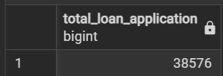
MTD LOAN APPLICATION
select count(id) as MTD_Total_loan_Application
from loan_data
WHERE
extract (MONTH from issue_date) = 12
and
extract (year from issue_date) = 2021;

PMTD LOAN APPLICATION
select count(id) as PMTD_Total_loan_Application
from loan_data
WHERE
extract (MONTH from issue_date) = 11
and
extract (year from issue_date) = 2021;
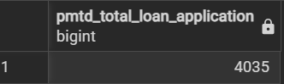
--(MTD - PMTD)/PMTD
Total Funded Amount
select sum(loan_amount) as Total_funded_Amount
from loan_data;
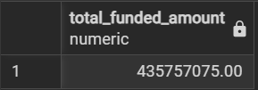
MTD Total Funded Amount
select sum(loan_amount) as MTD_Total_funded_Amount
from loan_data
where extract (MONTH From issue_date) = 12
and extract (YEAR From issue_date) = 2021;
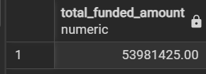
PMTD Total Funded Amount
select sum(loan_amount) as PMTD_Total_funded_Amount
from loan_data
where extract (MONTH From issue_date) = 11
and extract (YEAR From issue_date) = 2021; 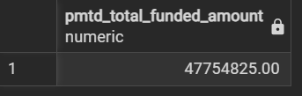
Total Amount Received
SELECT SUM(total_payment) AS Total_Amount_Received
from loan_data;
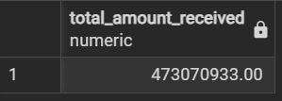
MTD Total Amount Received
SELECT SUM(total_payment) AS MTD_Total_Amount_Received
from loan_data
where extract (month from issue_date) = 12
and extract (YEAR from issue_date) = 2021;
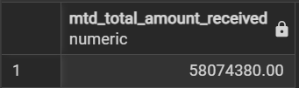
PMTD Total Amount Received
SELECT SUM(total_payment) AS PMTD_Total_Amount_Received
from loan_data
where extract (month from issue_date) = 11
and extract (YEAR from issue_date) = 2021;
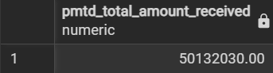
Average interest rate
SELECT ROUND(AVG(int_rate)*100, 2) AS Average_interest_rate
From loan_data;
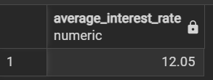
MTD Average interest rate
SELECT ROUND(AVG(int_rate)*100, 4) AS MTD_Average_interest_rate
From loan_data
where extract (month from issue_date) = 12
and extract (YEAR from issue_date) = 2021;
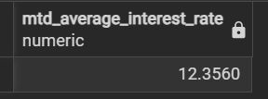
PMTD Average interest rate
SELECT ROUND(AVG(int_rate)*100, 4) AS PMTD_Average_interest_rate
From loan_data
where extract (month from issue_date) = 11
and extract (YEAR from issue_date) = 2021;
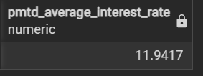
Average DTI
SELECT ROUND(AVG(dti)*100,4) as Avg_DTI
from loan_data;
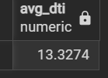
MTD Average DTI
SELECT ROUND(AVG(dti)*100,4) as MTD_Avg_DTI
from loan_data
where extract (month from issue_date) = 12
and extract (YEAR from issue_date) = 2021;
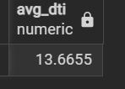
PMTD Average DTI
SELECT ROUND(AVG(dti)*100,4) as PMTD_Avg_DTI
from loan_data
where extract (month from issue_date) = 11
and extract (YEAR from issue_date) = 2021;
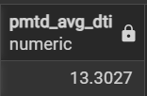
GOOD LOAN ISSUED
Good Loan Application Percentage
SELECT
(COUNT (CASE WHEN loan_status = 'Fully Paid' OR loan_status = 'Current' then id END
)* 100) / count(id)as Good_loan_percentage
from loan_data;
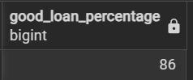
Good Loan Application
select count(id) as Good_loan_Application from loan_data
where loan_status = 'Fully Paid' OR loan_status = 'Current' ;
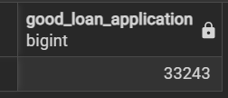
Good Loan Funded Amount
select Sum(loan_amount) as Good_loan_Funded_Amount from loan_data
where loan_status = 'Fully Paid' OR loan_status = 'Current' ;
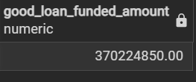
Good Loan Total Received Amount
select Sum(total_payment) as Good_loan_Total_Receieved_Amount from loan_data
where loan_status = 'Fully Paid' OR loan_status = 'Current' ;
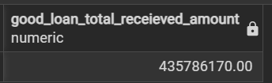
BAD LOAN ISSUED
Bad Loan Application Percentage
SELECT
(COUNT (CASE WHEN loan_status = 'Charged Off' then id END)* 100) / count(id)
as Bad_loan_percentage from loan_data;
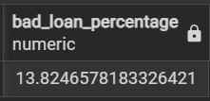
Bad Loan Application
select count(id) as Bad_loan_Application from loan_data
where loan_status = 'Charged Off' ;
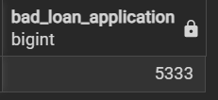
Bad Loan Funded Amount
select sum(loan_amount) as Bad_loan_funded_amount from loan_data
where loan_status = 'Charged Off' ;
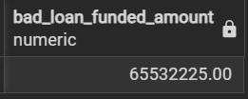
Bad Loan Amount Received
select sum(total_payment) as Bad_loan_amount_Receieved from loan_data
where loan_status = 'Charged Off' ;
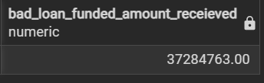
Loan Status Grid view
SELECT
loan_status,
count(id) as Total_Loan_application,
Sum(total_payment) as Total_Amount_Received,
sum(loan_amount) as Total_Funded_amount,
avg(int_rate *100) as Interest_rate,
avg(dti*100) as DTI
from
loan_data
group by
loan_status
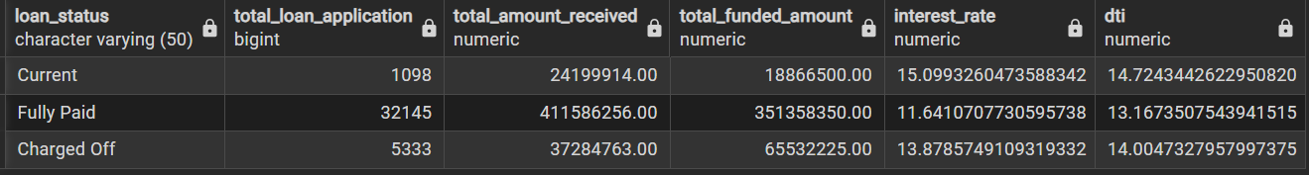
SELECT
loan_status,
Sum(total_payment) as MTD_Total_Amount_Received,
sum(loan_amount) as MTD_Total_Funded_amount
from
loan_data
WHERE EXTRACT(MONTH FROM issue_date) = 12
group by
loan_status
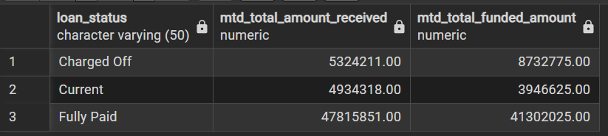
DASHBOARD 2: OVERVIEW
MONTHLY TREND
SELECT
EXTRACT(MONTH FROM issue_date) AS month_number,
TO_CHAR(issue_date, 'Mon') AS month_name,
COUNT(id) AS Total_Loan_Applications,
SUM(loan_amount) AS Total_loan_funded_amount,
SUM(total_payment) AS Total_received_amount
FROM loan_data
GROUP BY
EXTRACT(MONTH FROM issue_date),
TO_CHAR(issue_date, 'Mon')
ORDER BY month_number;
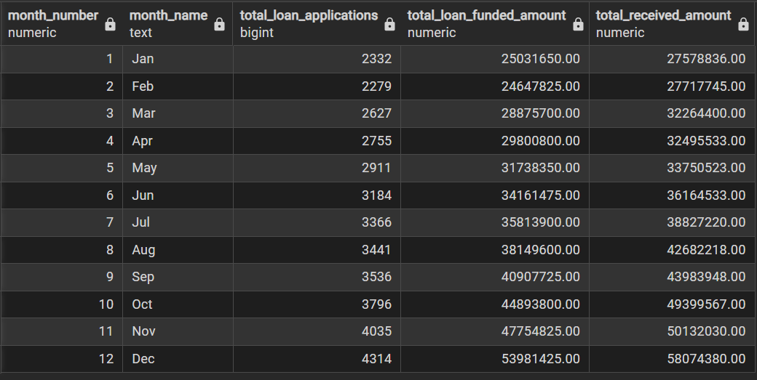
REGIONAL ANALYSIS
SELECT
address_state,
count(id) as Total_Loan_Applications,
Sum(total_payment) as Total_Amount_Received,
sum(loan_amount) as Total_Funded_amount
from
loan_data
group by
address_state
order by
sum(loan_amount) desc;
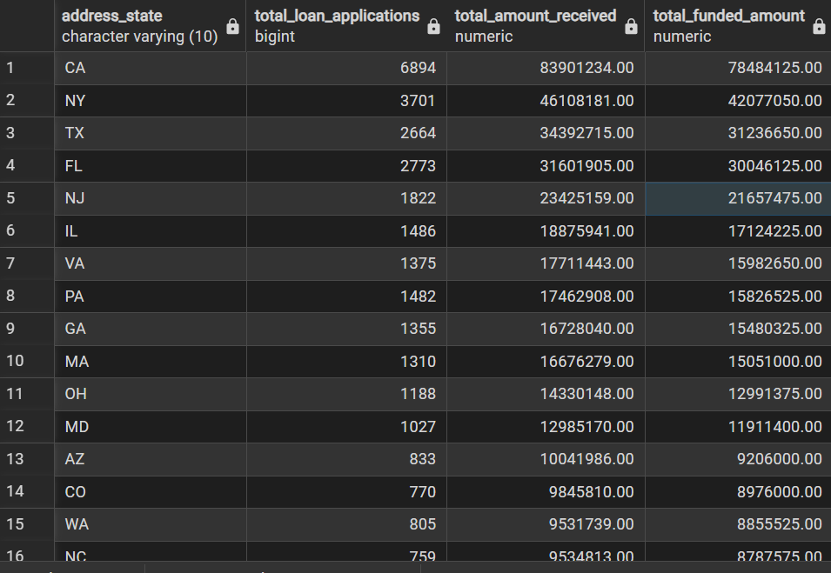
LOAN TERM ANALYSIS
SELECT
term,
count(id) as Total_Loan_Applications,
Sum(total_payment) as Total_Amount_Received,
sum(loan_amount) as Total_Funded_amount
from
loan_data
group by
term
order by
term;
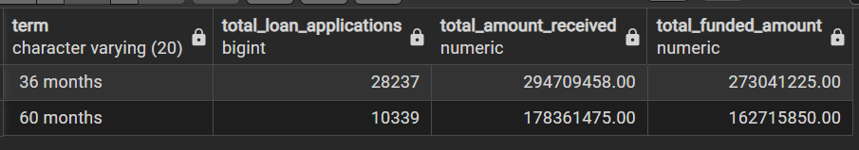
EMPLOYEE LENGTH ANALYSIS
SELECT
emp_length,
count(id) as Total_Loan_Applications,
Sum(total_payment) as Total_Amount_Received,
sum(loan_amount) as Total_Funded_amount
from
loan_data
group by
emp_length
order by
emp_length;
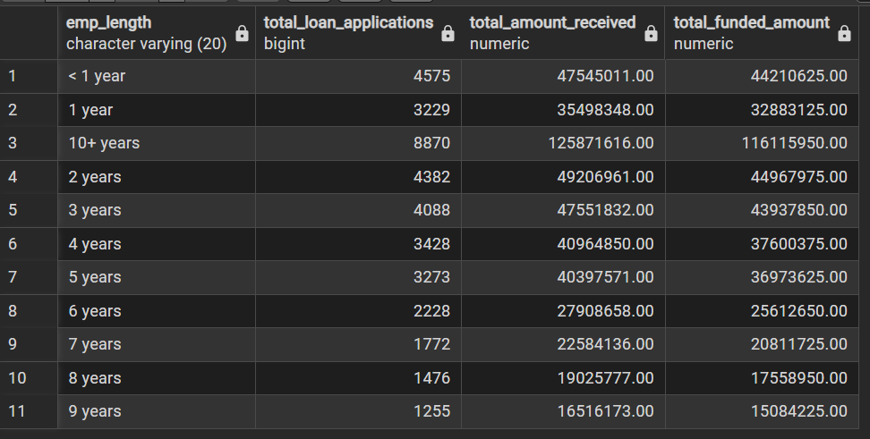
SELECT
emp_length,
count(id) as Total_Loan_Applications,
Sum(total_payment) as Total_Amount_Received,
sum(loan_amount) as Total_Funded_amount
from
loan_data
group by
emp_length
order by
count(id) desc;
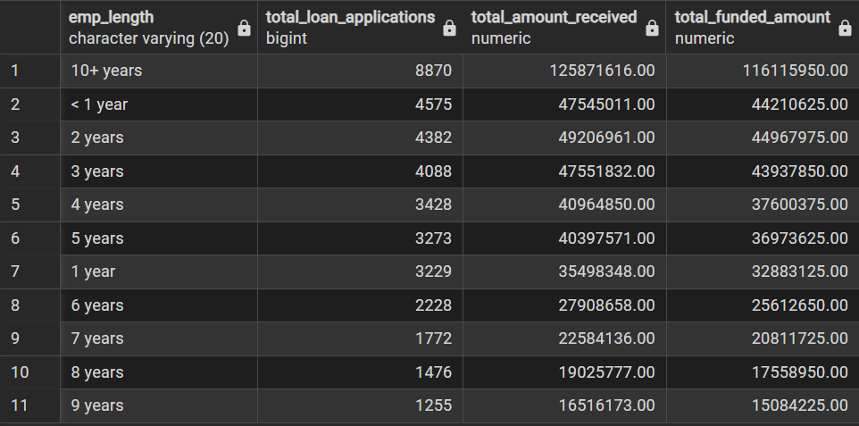
LOAN PURPOSE ANALYSIS
SELECT
purpose,
count(id) as Total_Loan_Applications,
Sum(total_payment) as Total_Amount_Received,
sum(loan_amount) as Total_Funded_amount
from
loan_data
group by
purpose
order by
count(id) desc;
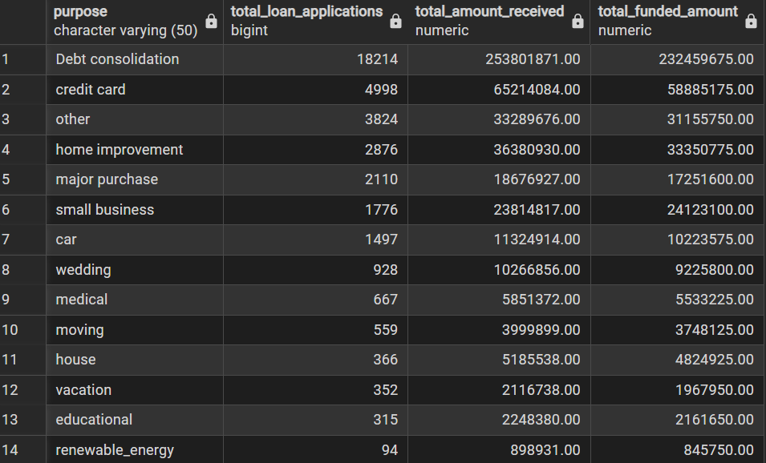
HOUSE OWNERSHIP ANALYSIS
SELECT
home_ownership,
count(id) as Total_Loan_Applications,
Sum(total_payment) as Total_Amount_Received,
sum(loan_amount) as Total_Funded_amount
from
loan_data
group by
home_ownership
order by
count(id) desc;
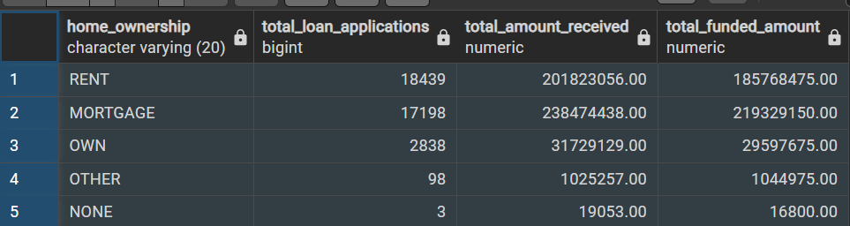
filter analysis
SELECT
home_ownership,
count(id) as Total_Loan_Applications,
Sum(total_payment) as Total_Amount_Received,
sum(loan_amount) as Total_Funded_amount
from
loan_data
WHERE grade = 'A' and address_state = 'CA'
group by
home_ownership
order by
count(id) desc;
